Technique of reinforced soil base calculation under fall initiation in ground mass
La méthode du compte armé les raisons du sol à l'apparition des échecs à le massif du sol
A. Ponomaryov & D. Zolotozubov.
Perm national research polytechnical university

ABSTRACT: On the basis of carried out investigations, the authors obtained stress and strain development mechanisms of the reinforced ground mass depending on the properties of soils, the characteristics of the reinforcing elements, the depth of their location and their number. The obtained mechanisms allowed to propose the calculation methodology of the reinforced base surface settlement in the territories expose to deformation. To evaluate the proposed method, it was compared with previously obtained results of the experiments and calculations carried out with the help of BS8006, Giroud, Perrier, R.A.F.A.E.L methods and PLAXIS and Sofistik programs.
RÉSUMÉ : À la base des études accomplies les auteurs ont reçu les mécanismes du développement de l'effort et l'effort de la masse affermie de la raison en fonction des propriétés des sols, les particularités des éléments du renforcement, la profondeur de leur situation et leur nombre. Les régularités reçues ont permis de proposer la méthode du compte le dépôt de la surface des raisons armées sur les territoires exposés aux déformations. Pour estimer la méthode proposée, c'était en comparaison d'auparavant résultats acquis des expériences et calculs accomplis avec l'aide de BS8006, Giroud, Perrier, les méthodes R.A.F.A.E.L et PLAXIS et les programmes Sofistik.
KEYWORDS: reinforced soils, fall in ground mass, technique of calculation.

- INTRODUCTION.
When laying foundations of buildings and structures in areas prone to possible vertical deformations (for instance, karstic and technogenic dolines), it is necessary to provide measures to prevent emergency situations.
The choice of measures depends on the type of security – perfect or partial. When it is sufficient to provide only partial security, geosynthetic material reinforcement of a ground base is most commonly used. It is connected with the fact that ground reinforcement is more economical as compared with other methods.
In Russia ground base reinforcement has not been used widely so far due to various factors, including both the increase in the cost of construction connected with the use of geosynthetics and sufficiently large amount of excavation works.
High quality geosynthetic materials themselves are not cheap, and large volumes of excavation arise from the need of a sufficiently deep placement of reinforcing layers. However, the use of local materials and a well-tried technology of reinforced base laying, as well as the increase in the safe upkeep of buildings, give a good economic effect.
- experimental investigations
Effective use of geosynthetics for reinforcement under ground mass collapse is possible with the joint account of such factors as physical and mechanical properties of foundation soil, tensile properties of geosynthetics, the depth of reinforcing layers and their number. The optimal choice of these parameters requires rather complex calculations taking into account load – elongation dependences. The existing methods (the method outlined in the British Standard BS 8006, section 8.4 (BSI, 1995 – Fig. 1), the method of Giroud et al (1990), the method of Perrier (1985); R.A.F.A.E.L. – method (Blivet et al, 2002) do not consider the actual tensile force – relative deformation ratio. They are applied for single-layer reinforcement. Being used to solve geotechnical problems, software packages that implement numerical methods give great inaccuracy, but at the same time they allow to calculate more quickly and check more types of reinforcement including those of multi-layer reinforcement.

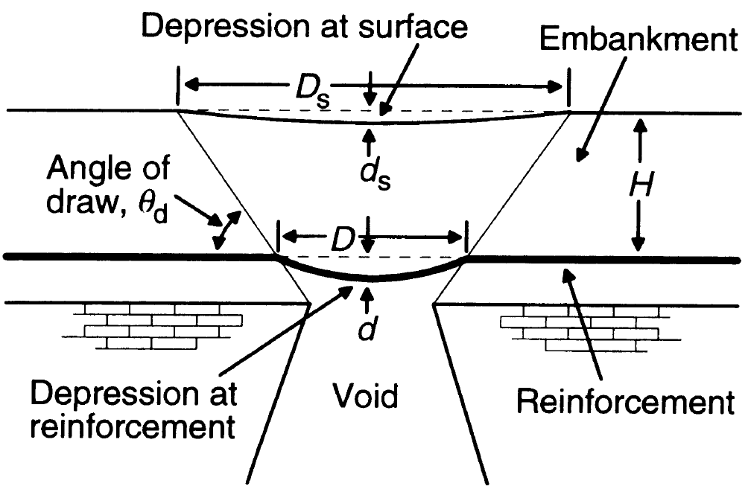
Figure 1. BS 8006: Parameters used to determine reinforcement.
The study of reinforced bases under ground mass collapse conducted by the authors allowed to obtain the mechanisms of stress – strain development in the reinforced ground mass depending on the foundation soil properties, the characteristics of the reinforcing elements, their depth and quantity. The results of S. Schwerdt’s investigations were also used in the study.
On the basis of the mechanisms obtained we proposed the technique for calculating the reinforced base surface settlement in areas prone to deformation. As in the above-mentioned methods, the calculations were carried out for single-layer reinforcement, but at the same time the change in elongation of the geosynthetic reinforcing material depending on the load was taken into account. To do calculations using this method it is necessary to have load – elongation dependences which are obtained when testing geosynthetics at rupture, in accordance with ISO 10319:2008 (Fig. 2).
In the course of our studies we were doing experiments with account of the current Russian regulations enabling to apply tensile-testing machines to ensure the constant rate of bottom clamp sinking, the constant strain rate or the fixed rate of load increase (similar to ISO 10319:2008) with relative error indications of breaking load ± 1.0 %, with absolute error indications of elongation ± 1.0 mm, with an average rupture duration regulated from (30±15) to (60±15) sec.

In practice, we had to build these relationships using the results obtained with the help of the tensile-testing machine that provided the constant rate of bottom clamp sinking (Fig. 3, 4).

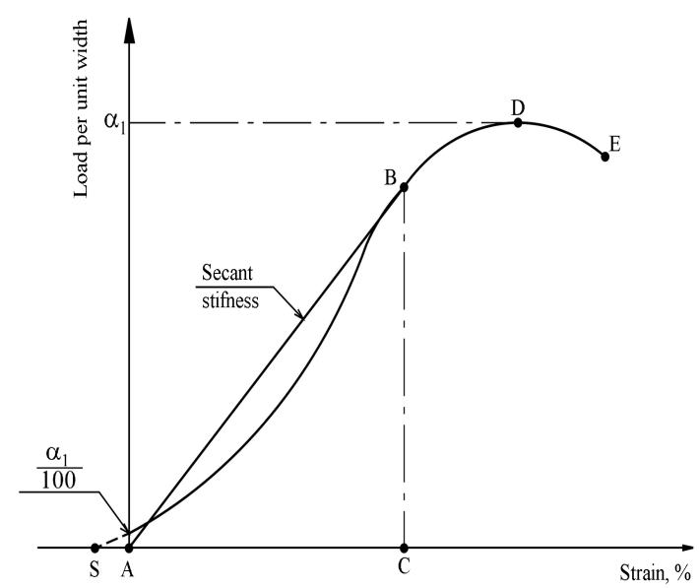
Figure 2. Typical load-elongation curve.

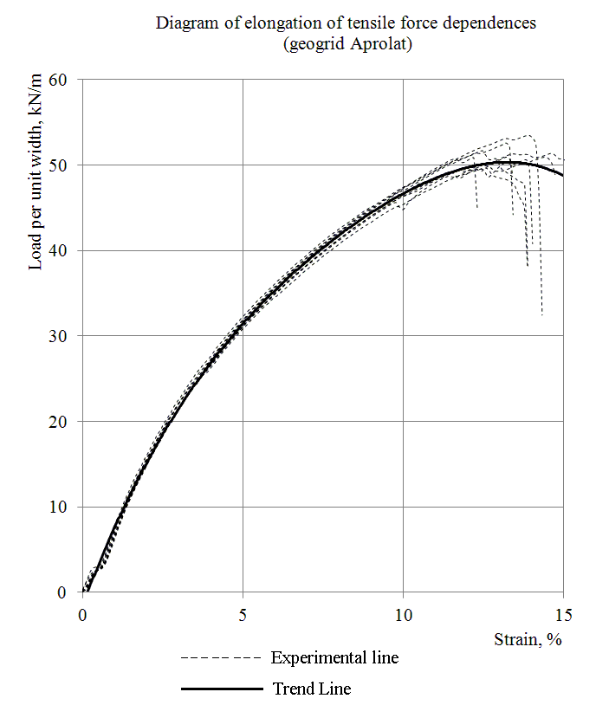
Figure 3. Example of elongation-load curve according to the test results.
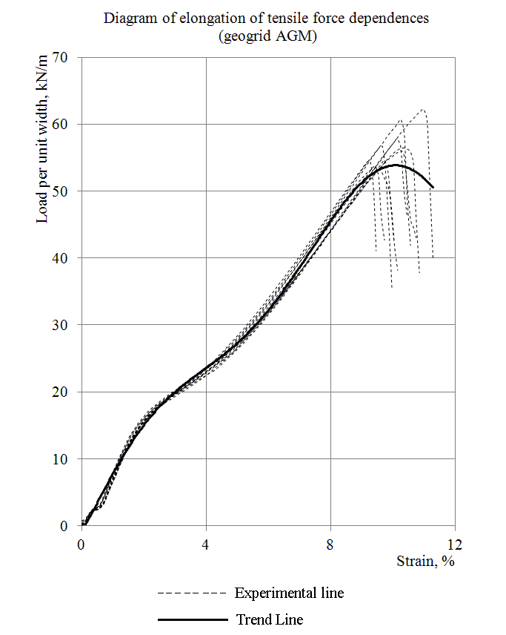
Figure 4. Example of elongation-load curve according to the test results.
The obtained dependences were used in the calculations done with the help of both numerical methods (PLAXIS program) and the developed technique.
- Technique of reinforced soil base calculation
The design scheme of the proposed method is shown in Figure 5.

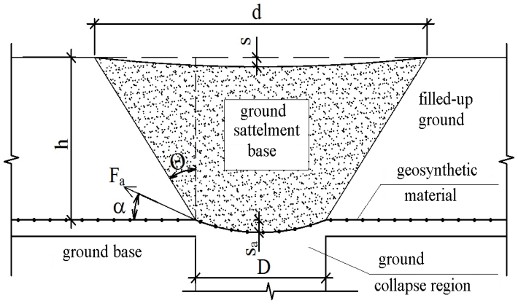

Figure 5. Design diagram of reinforced ground settlement under earth collapse.
In this method the following assumptions allowing to use formulas well-known in soil mechanics for the calculation of stresses in ground bases were made:
− the reinforced ground mass is in an equilibrium (stabilized) state before the ground collapse formation;
– the reinforcing layer is located in the homogeneous ground;
– the stress-strain state is considered at that moment when the marginal state of the ground mass is reached;
− the deformation form of the ground mass above the reinforcing interlayer has a sectional view of a trapezoid;
− the geosynthetic material does not stretch beyond the collapse region;
− the arch effect is not taken into account.
The algorithm for calculating the proposed technique is based on the tensile force dependence in the geosynthetics F_{a} on the size and shape of the collapse, the reinforcing interlayer depth, the surface load and geosynthetic material elongation . Our studies showed that the tensile force – elongation dependence is determined most accurately with the use of the formula similar to that in the BS 8006 standard

, (1)

where k is the coefficient taking into account the supposed form of the collapse (for the rectangular collapse – plane problem – it is equal to 1). In the British standard BS 8006 the value of 0.67 for the axisymmetric case is given , but studies showed that higher convergence with the experimental results was obtained when k = 0.78; ε_{a} is the specific elongation of the geosynthetic material depending on the tensile force in the reinforcing interlayer, which is determined according to the graphs (for example, as shown in Fig. 2); h is the depth of the reinforcing layer, m; γ is the specific weight of the ground, which is located above the reinforcing interlayer, kN/m³. If there are ground layers having different specific weight values and located above the reinforcing interlayer, it is necessary to make the following replacement in the formula

where n is the number of ground layers above the reinforcing interlayer, γ_{i} is the specific weight of the i-th ground layer, h_{i} is the height of the i-th ground layer; q is the equivalent surface load on the reinforcing layer, кН/м. Its calculation depends on the surface load amount by analogy with the calculation of the additional pressure (tension) in the ground mass, as well as on the load type, the load area-to-collapse region ratio, the surface load location with respect to the ground collapse; D is the collapse length (diameter), m.
The main problem when calculating by this method is that at the initial calculation stage we are aware of neither the tensile force F_{a}, nor the specific elongation of the geosynthetic material ε_{a} because the actual dependence of the elongation on the tensile load is not taken into account in the formula (1). That’s why, we used the successive approximations method accurate to 5 %. The received value ε_{a} is used to determine the maximum deflection s_{a} of the reinforcing material

. (2)

To calculate the maximum ground surface settlement, the following formula is used,
, (3)

where θ is the inclination angle of the slip plane to the vertical. The values θ depend on the characteristics of the backfill soil. Since it is necessary to determine the maximum surface settlement by the current Russian regulations, in practical calculations θ=ϕ is taken. In case the ground layers located above the reinforcing interlayer have different ϕ values, the following value is used.

The obtained value of the surface settlement s is compared with the normative or design values for this construction project. If the condition s ≤ s_{и} is not satisfied, then a geosynthetic material with different characteristics is selected and the calculation is done again.
To evaluate the proposed method, its comparison with the results of the experiments and calculations performed by other methods (BS8006, Giroud, Perrier, R.A.F.A.E.L.) as well as PLAXIS and Sofistik programs was carried out. Due to the fact that we were not able to do model experiments in Russia, the data for comparison were taken from Schwerdt’s works.

Table 1. Results of calculations
Calculation method | Tensile force in geosynthetic material , kN/m | Deflection of geosynthetic material, mm | Surface settlement, mm
Experiment | 105 | 90 | 30
BS8006 | 64 | 240 | 30*
Giroud | 215,5 | 90* | 30*
Perrier | 120 | 90 | 90
R.A.F.A.E.L. | 95,8 | 120 | –**
PLAXIS | 103 | 160 | –
Sofistik | 113 | 130 | –***
Proposed method | 114,5 | 107 | 34
*-These are initial data according to the indicated methods.
**-Negative values are received.
***-The Sofistik program does not allow to determine the surface settlement.
- references
Blivet et. al. Design method for geosynthetics as reinforcement for embankment subjected to localized subsidence. Delmas; Gourc; Girard (ed): Geosynthetics 7. ICG, 2002/ Swets & Zeitlinger.
BS 8006: 1995. Code of Practice for Strengthened/Reinforced soil and Other Fill, British Standart Institution. Section 8. Design of embankment with reinforced soil foundation on poor ground. p. 98–121.
Giroud J.P., Bonaparte R.; Beech J.F. Design of Soil Layer- Geosynthetic Systems overlying Voids. Geotextiles und Geomembranes //9Jg, H. 1 – 1990. – S.11-50.
Schwerdt, S. 2003. Die Ueberbrueckung von Erdeinbruechen unter Verwendung von einlagig verlegten Geogittern - Vergleich zwischen Versuchsergebnissen und den Ergebnissen von analytischen und numerischen Berechnungen. Geotechnik, 26: 95-105.
Schwerdt, S., Naciri, O., Jenner, C.G. 2004. Performance of aggregates in geogrid-reinforced soils used for protection against surface collapse into underground voids. In EuroGeo 3: Geosyntetics conference, Munich, Germany: 483-488.
Pappiau Ch., Baraize E.; Perrier H. Motorway level fortification above carstic cavities. eotextiles –Geomembranes rencontres. 1995. Tome 1. S. 93-99
Paul A., Schwerdt S. Untersuchungen zur Uеberbrueckung von Tagesbruechen und Erdfaellen durch Einbau einer einlagigen Geokunststoffbewehrung. Proc. 7. Informations- und Vortragstaguung Kunststoffe in der Geotechnik, Muenchen, 2001 S. 251-257.
Ponomaryov, A.B., Zolotozubov, D.G. Effect of reinforcing material depth on bearing capacity of foundation under ground collapse. Herald of Civil Engineers, 2 (23), 2010: 100-104.
Zolotozubov, D.G., Ponomaryov, A.B. Structural protection of ground bases under collapse initiation in karst areas. Herald of Volgograd State University of Architecture and Civil Engineering. Section: Construction and architecture 15 (34), 2009: 15-18.

